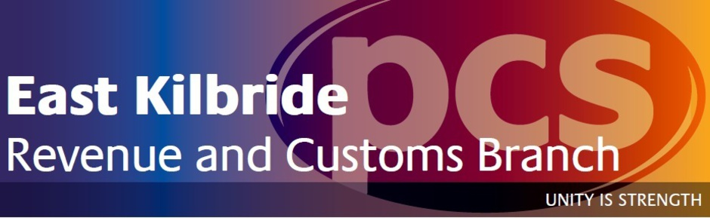
Branch Annual General Meeting
Calling Notice
Dear colleague,
We would like to invite you to attend the 2017 East Kilbride Branch Annual General Meeting. This meeting is your opportunity to hear from the Branch Executive Committee and discuss the work undertaken on your behalf in the previous year as well as electing your representatives and helping to set the agenda for your Union for the year ahead through motions for HMRC Group and PCS National Delegate Conference 2017.
The Branch AGM will be taking place in Queensway House on Thursday 2nd March 2017 from 2:30pm in the staff canteen area. Attendance is in members own time but we strongly encourage all members to attend this important meeting and have your say. In order to minimise the impact on members, we have reduced the time of the AGM to one hour.
Attached to this notice is information regarding the posts available for nomination at the AGM as well as how to submit motions to the meeting for debate. If you require any additional information then please contact your local rep who will be able to assist.
If you have any additional requirements in order to attend this meeting then please contact Kris Hendry, Branch Secretary, to advise and we will endeavour to facilitate any requests.
We look forward to seeing you at this year’s Branch AGM.
Regards
Kris Hendry
Revenue & Customs East Kilbride Branch Secretary
Branch Elections
Branch Executive Committee
The following posts are open to members for nomination on the Branch Executive Committee for 2017/2018 (Number in bracket indicates total posts available):
Branch Chair (1) Branch Vice Chair (1)
Branch Secretary (1) Branch Treasurer (1)
Branch Organiser (1) Branch Health & Safety Chair (1)
Branch Learning Coordinator (1) Branch Equality & Diversity Officer (1)
Branch BAME Officer (1) Branch Disabled Members Officer (1)
Branch LGBT Members Officer (1) Branch Women Members Officer (1)
Branch Young Members Officer (1)

Additional Branch Positions
Members can also nominate themselves for the following additional Branch positions:
Branch Women’s Advisory Committee (6)
Branch Young Members Advisory Committee (6)
Branch Auditor (2)
Scrutineer* (2) *elected at AGM

All nominations for Branch vacancies should be submitted to Branch Secretary Kris Hendry no later than 12pm on Thursday 23rd February with your name and post nominated for using subject heading ‘Branch Nomination’.
In the event the number of nominations exceeds the total number of posts available for any position then a ballot of members shall be carried out with the decision announced at the Annual General Meeting.

Group Elections
Group Conference Delegate
Members are entitled to nominate themselves to represent the Branch as delegate to the Revenue & Customs Group Conference which will be held on Monday 22nd May and the morning of Tuesday 23rd May. Delegates will be expected to represent the views of local members during debates and voting on motions submitted to Group Conference.
The Branch is permitted to send up to 4 delegates to Group Conference with costs for travel and subsistence covered by PCS for delegates although attendance will be in members own time.
In the event more nominations than available posts are received then delegates will be determined by a vote of members present at the Annual General Meeting.

Group Executive Committee
The following posts are open to members for nomination on the Group Executive Committee for 2017/2018 (Number in bracket indicates total posts available):
Group President (1) Deputy President (1)
Deputy Group Secretary (1) Assistant Group Secretary (8)
Group Treasurer (1) Group Executive Committee member (19)
Members nominated for these positions will be required to complete an acceptance of nomination form and submit an election statement for their nomination to be valid. These posts will be subject to election (If required) prior to Group Conference.

Additional Group Positions
Members can also nominate themselves for the following additional Group positions:
Group Standing Orders Committee (3) Group Auditors (2)
Group Editorial Board (3)
Group Environmental Advisory Committee (6)
Group Black Members’ Advisory Committee (8)
Group Disabled Members’ Advisory Committee (8)
Group LGBT Advisory Committee (8)
Group Women’s Advisory Committee (8)
Group Young Members’ Advisory Committee (8)
Members nominated for these positions will be required to complete an acceptance of nomination form and submit an election address for their nomination to be valid. These posts will be subject to election (if required) at Group Conference.

All nominations for Group vacancies should be submitted to Branch Secretary Kris Hendry no later than 12pm on Thursday 23rd February with your name and post nominated for using subject heading ‘Group Nomination’.

National Elections
Annual Delegate Conference Delegate
Members are entitled to nominate themselves to represent the Branch as delegate to the PCS Annual Delegate Conference which will be held on the afternoon of Tuesday 23rd May, Wednesday 24th May and the morning of Thursday 25th May 2017.. Delegates will be expected to represent the views of local members during debates and voting on motions submitted to Conference.
The Branch is permitted to send up to 4 delegates to Conference with costs for travel and subsistence covered by PCS for delegates although attendance will be in members own time.
In the event more nominations than available posts are received then delegates will be determined by a vote of members present at the Annual General Meeting.

National Executive Committee
The following posts are open to members for nomination on the National Executive Committee for 2017/2018 (Number in bracket indicates total posts available):
National President (1)
Deputy/Vice Presidents (4 – the nominee with most votes will become Deputy President with the remaining three becoming Vice Presidents)
Ordinary NEC Member (30)
Members nominated for these positions will be required to complete an acceptance of nomination form and submit an election statement for their nomination to be valid. These posts will be subject to election (If required) prior to Annual Delegate Conference.

Additional National Positions
Members can also nominate themselves for the following additional Group positions:
Member Trustees (1) Editorial Board(5)
Trades Union Congress Delegate (6)
TUC Women’s Conference Delegate (3)
TUC Youth Conference Delegate* (2)
Scottish Trades Union Congress Delegate (4)
STUC Women’s Conference Delegate (2)
STUC Youth Conference Delegate** (2)
Wales Trades Union Conference Delegate (3)
* To meet TUC Youth Conference requirements, nominees must be aged 27 or under at the start of the Conference they are nominated to attend
**To meet STUC Youth Conference requirements, nominees must be aged 26 or under at the start of the Conference they are nominated to attend
Members nominated for these positions will be required to complete an acceptance of nomination form and submit an election address for their nomination to be valid. These posts will be subject to election (if required) at Annual Delegate Conference.

All nominations for National vacancies should be submitted to Branch Secretary Kris Hendry no later than 12pm on Thursday 23rd February with your name and post nominated for using subject heading ‘National Nomination’.

Motions
All members are entitled to submit motions to the Branch Annual General Meeting. These motions are how members can help to direct the agenda of PCS and their representatives.
Motions can be submitted for the Branch themselves, Group or National Conference. All motions received and accepted will be debated at the Annual General Meeting and once the debate has been heard then members in attendance will vote on the motion and, if passed, will be taken forward as appropriate.
For motions to the Branch then the incoming Branch Executive Committee will be responsible for implementing the instructions contained within the motion. Group or National motions will be submitted as appropriate and those elected as delegates will be responsible for moving the motion at the relevant Conference and again, if passed, this then becomes policy for the incoming Group or National Executive Committee to action.
Writing a motion does not need to be particularly difficult or complex, some points to consider are:
- What is the issue that needs to be debated?
- How does it affect members?
- What difference will a change in policy/taking action make?
- Instructions are essential for a motion to be considered eg “The BEC/GEC/NEC is instructed to…”
- Be sure to keep your motion clear and concise

All motions should be submitted to Branch Secretary Kris Hendry no later than 12pm on Thursday 23rd February. Members should indicate on the subject line if their motion is a ‘Branch motion’, ‘Group motion’ or ‘National motion’.

A full agenda will be published on the Branch website along with the Branch Annual Report and Financial Report no later than 24 hours prior to the Annual General Meeting.

